The wireframe of additional test.

The 1st button shows a list of all the runners for an age that is a prime number.

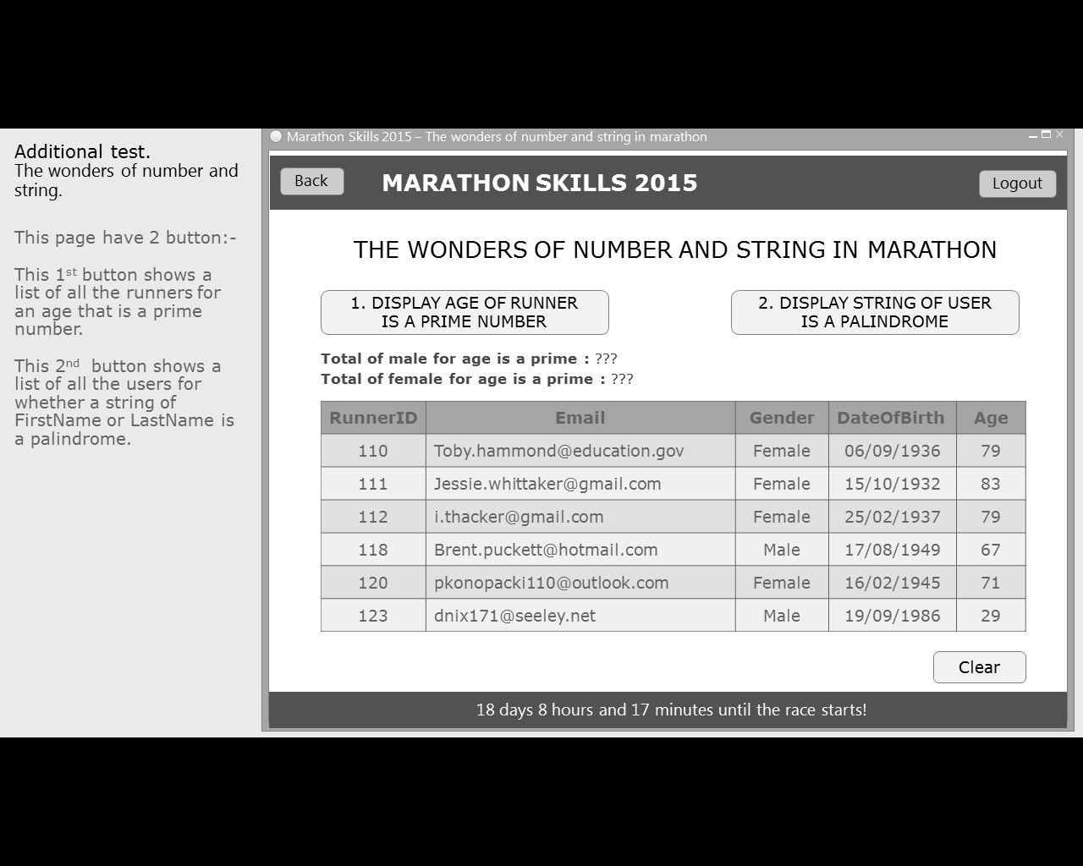

The 2nd button shows a list of all the users for whether a string of FirstName or LastName is a palindrome.

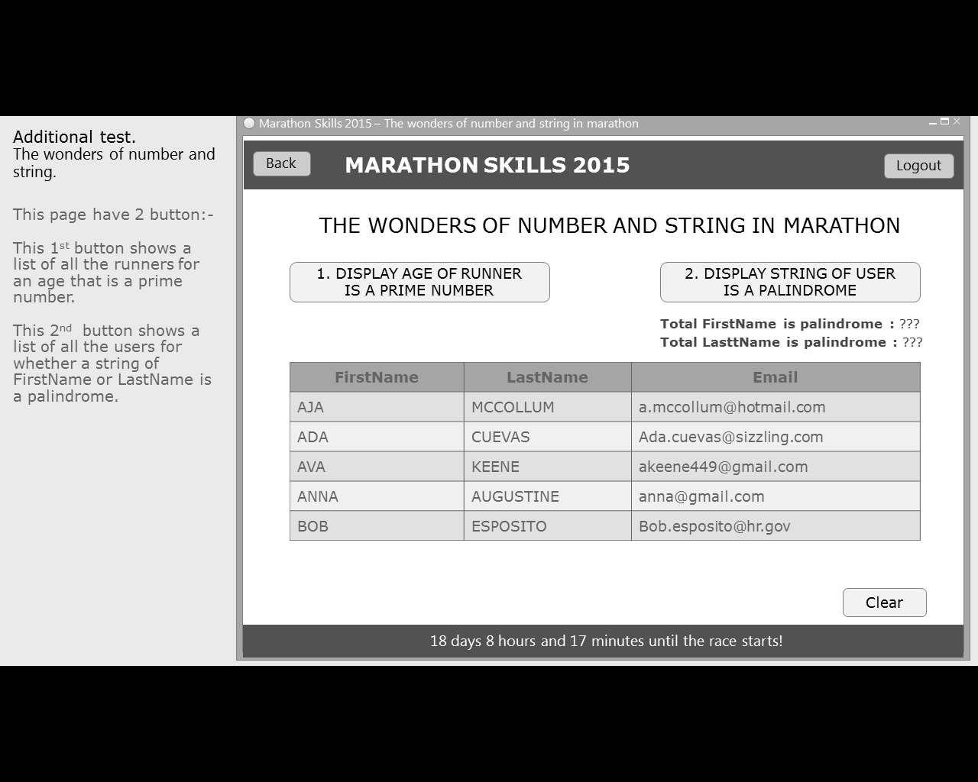

Remark : The result of 2 button must show same window